Research on Falcon Imaging Device

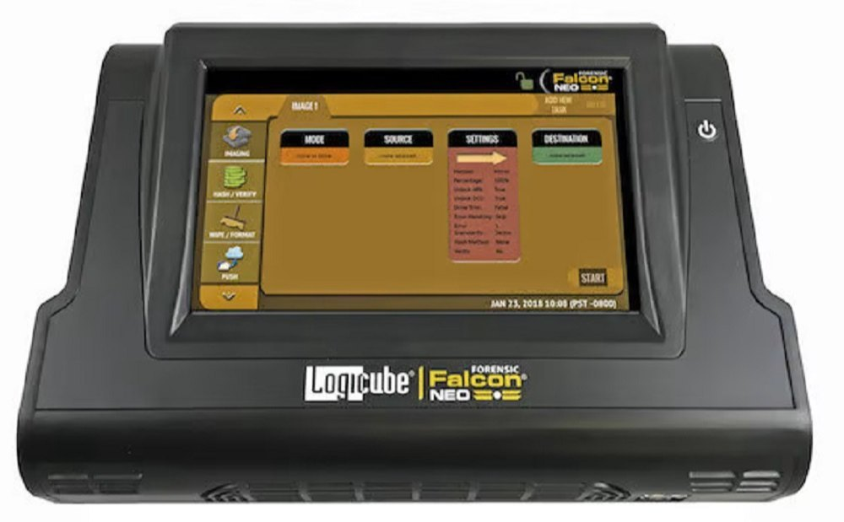

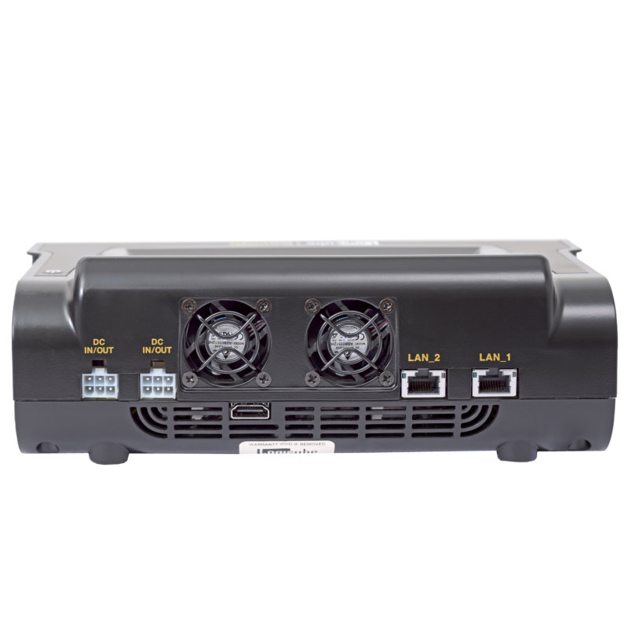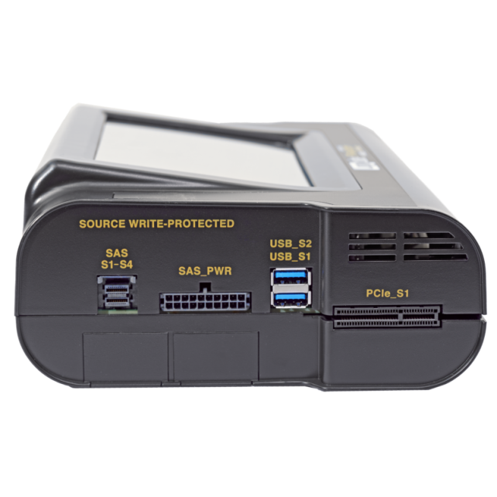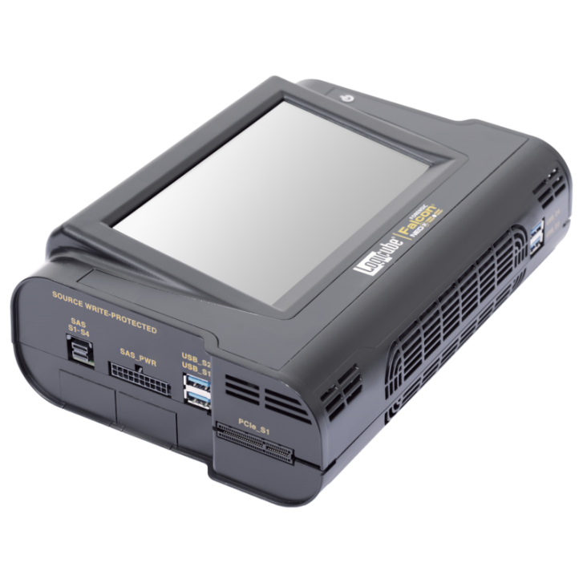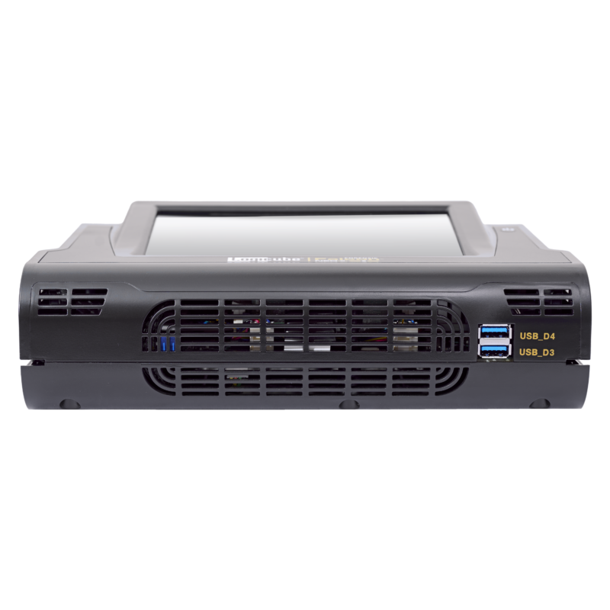

**What is Falcon Imaging Device?**

The Falcon Imaging Device is a piece of special equipment used by cyber detectives and forensic experts to investigate computers and other digital devices. It's like a super camera and a smart tool combined!

**How is it Used?**

1. **Data Extraction**: Just like a camera takes pictures, the Falcon Imaging Device takes "pictures" of the information stored on computers and devices. This includes things like photos, documents, emails, and even deleted files that someone might try to hide.
2. **Preservation of Evidence**: When there’s a crime involving computers, experts use Falcon to carefully copy all the information from the device. This way, they have a complete record of everything that was on it at the time of the investigation.
3. **Analysis**: After copying the data, forensic experts use special software to analyze it. They look for clues that can tell them who did something bad, what they did, and when they did it. This helps solve crimes involving computers, like hacking or stealing information.
4. **Court Evidence**: The information gathered by Falcon can be used as evidence in court. It helps explain what happened and proves who is responsible for the crime.

### Example Scenario: Using Falcon Imaging Device

Imagine someone’s computer is used to hack into a school’s system and change grades. Here’s how Falcon might be used:

* **Data Extraction**: The Falcon Imaging Device connects to the suspect’s computer. It carefully copies all the files, emails, and internet history from the computer’s hard drive.
* **Analysis**: Forensic experts analyze the copied data using Falcon’s software. They find evidence showing that someone used the computer to log into the school system and change grades.
* **Finding Clues**: They discover deleted files that the hacker tried to erase. These files contain clues like emails between the hacker and others involved in the crime.
* **Evidence for Court**: The evidence collected by Falcon is used in court to prove who hacked the school system and changed the grades.

### Why Falcon Imaging Device is Important

* **Helps Solve Crimes**: It’s crucial in catching criminals who use computers to commit crimes like hacking or fraud.
* **Preserves Evidence**: Ensures that all the information is copied accurately so it can be used in investigations and trials.
* **Protects People**: By finding and stopping cybercriminals, Falcon helps keep people’s information safe and secure online.

In conclusion, Falcon Imaging Device is a high-tech tool used in cyber forensics to investigate and solve crimes involving computers and digital devices. It’s like a digital detective that helps experts find out who did something bad online and how they did it.

**Pricing:**

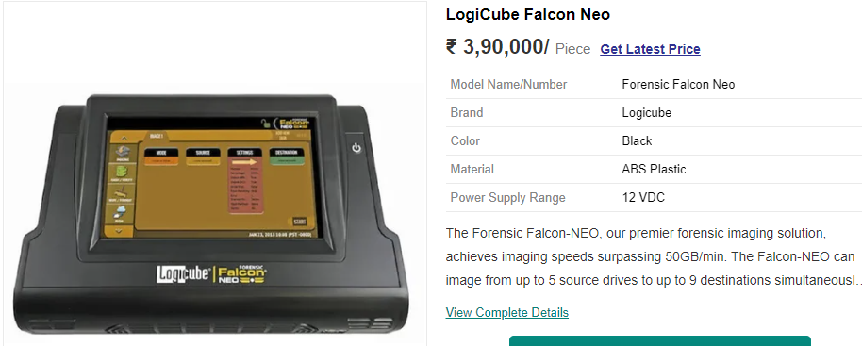

**Product Description**

The Forensic Falcon-NEO, our premier forensic imaging solution, achieves imaging speeds surpassing 50GB/min. The Falcon-NEO can image from up to 5 source drives to up to 9 destinations simultaneously to provide efficient and secure digital evidence collection. The solution can image to/from a network repository with two 10GbE ports. The future-focused Falcon-NEO is designed to streamline the evidence collection process.  
The next-generation of our ground-breaking Forensic Falcon®, the Falcon®-NEO achieves imaging speeds surpassing 50GB/min imaging speed*. Efficient and secure digital evidence collection is accomplished with a feature-set that provides sophisticated functionality with a goal to shorten acquisition time. Designed to meet future technological advances in digital forensics, the Falcon-NEO sets new standards in forensic imaging technology.

* Extreme speed, imaging at surpassing 50GB/min*. Clone PCIe to PCIe at speeds over 90GB/min.
* Image directly to/from Thunderbolt™ 3/USB-C external storage enclosures with an optional I/O card.
* Image & verify from up to 5 source to up to 9 destination drives for ultra-efficient imaging.
* Concurrent Image+Verify feature. Verification starts shortly after imaging process begins, significantly reducing the image plus verification process time.
* Image to/from Fibre Channel drives and enclosures with the optional Fibre Channel Module.
* Recognize source drives and partitions that are possibly encrypted.
* Cloud storage acquisition software renewable option provides convenient capture of OneDrive, Google Drive, and Dropbox files.
* Capture from mobile devices including Apple® iPhones, iPads, Android phones and tablets with an optional renewable software package.
* Secure Erase NVMe SSDs.
* File Browser/write-blocked drive preview feature provides logical access to drives and network repositories connected to Falcon-NEO. View contents of dd, e01, ex01, and dmg image files created by Falcon-NEO.
* Secure sensitive evidence data with whole disk, open standard, drive encryption using the NIST recommended XTS-AES-256 cipher mode, decrypt using Falcon-NEO or Veracrypt.
* Logical Imaging feature creates a logical image using pre-set, custom filters, file signature files and keyword search to capture only specific files needed.
* Image to/from a network location using two 10GbE connections for fast network imaging performance and to minimize bottlenecks.
* Image from a laptop using our iSCSI boot client or from a Mac®computer using Target Disk Mode without removing the hard drive.
* Multi-task. Perform image, wipe, hash tasks simultaneously. Little or no speed degradation when imaging from three sources to three destinations.
* S.M.A.R.T. reporting for all drives involved in Drive to File, Drive to Drive, and Wipe tasks.
* Network Traffic Capture. Capture network traffic, VOIP, internet activity